Determination of the Concentration of an Unknown Methylene Blue Solution Using Spectrophotometry
ID No:15389583
College of Engineering, Environment, and Sciences, Coventry University
4008BIO-Structure, Function and Analysis of Biomolecules
Dr. Shadi Bokaee
25 November, 2024

Introduction
Methylene blue, an organic salt, is a common dye used to stain biological substances such as tissue, cells, or specific organelles such as nuclei in the nucleus. According to the book written by Bistas and Sanghavi (2023), this dye can also be used as a treatment for methemoglobinemia, a disease that causes haemoglobins to malfunction. Knowing the right cure concentration injected or consumed is crucial when treating an illness. A method called spectrophotometry is employed to find an unknown concentration of chemicals.
Spectrophotometry measures the absorbance of light in specific wavelengths in compounds, which can be calculated to the concentration of the solution. Mainly, in a spectrophotometer, two light sources, ultraviolet (UV) and infrared (IR) lights, penetrate the sample. The reason why various types of lights are used is that the wavelengths of these lights can differ in the reaction. This interaction between matter and light leads matter molecules to absorb or transmit light energy. (Morris, 2015)
To measure this absorption accurately, the lambda max value must be determined. Lambda max (λmax) is a wavelength value of a spectrophotometer which can be found where the absorbance of the same sample is the highest. This implies that at lambda max, the measured sample reacts the most sensitively therefore giving the most desirable outcomes. The relationship between these two is further explained by Beer-Lambert law.
Beer-Lambert law clarifies how the attenuation of light affects the substance it travels through as follows:
$A= εcl$ (1)
Equation 1 describes beer-lambert law where A is the absorbance, ε is the molar absorptivity coefficient, c is the concentration of the absorbing material, and l is the path length of the sample. Knowing the lambda max value is advantageous when using this law. As claimed by the researcher Mamouei et al. (2021), the highest molar absorptivity coefficient value, which represents how well the matter molecule absorbs light, is set at lambda max. (Lee et al., 2015) This coefficient results in the strongest relationship between absorbance and concentration. This link can be interpreted as the absorption of light directly proportional to the concentration of the absorbing substance. (Oshina and Spigulis, 2021) Beer-Lambert law indicates that if the equation of the relation between absorbance and concentration is once set, then either absorbance or concentration can be calculated if the value of the other one exists.
The purpose of this experiment, which determines the concentration of an unknown solution using spectrophotometry, is to comprehend how spectrophotometry operates, use the spectrophotometer correctly, and also apprehend further uses of spectrophotometry. Understanding these is imperative to building the knowledge and skill base to become a researcher, technician, or scientist.
Methods
The experiment was conducted under the experiment sequence given by Coventry University (2024). The Calibration was done according to Table 1.
Table 1
Calibration Curve Method for Dye Solution
Test tubes  (duplicates) | S₀  a/b | S₁  a/b | S₂  a/b | S₃  a/b | S₄  a/b | S₅  a/b | X  a/b
Final [dye] (μg/ml) | 0 | 1 | 2 | 3 | 4 | 5 | -
Standard Dye Solution (ml) | 0.0 | 0.5 | 1.0 | 1.5 | 2.0 | 2.5 | -
Distilled water (ml) | 2.5 | 2.0 | 1.5 | 1.0 | 0.5 | 0.0 | -
Unknown dye solution (X) (ml) | - | - | - | - | - | - | 2.5

Results
The experiment was conducted precisely following the methods and the results from each step were recorded in table forms and transferred to the figures.
Table 2
Absorption Curve Data for the Methylene Blue Dye
Wavelength  (nm) | Absorbance | Wavelength  (nm) | Absorbance | Wavelength  (nm) | Absorbance
500 | 0.038 | 570 | 0.15 | 640 | 0.634
510 | 0.033 | 580 | 0.203 | 650 | 0.79
520 | 0.055 | 590 | 0.285 | 660 | 0.945
530 | 0.05 | 600 | 0.4 | 670 | 0.989
540 | 0.06 | 610 | 0.506 | 680 | 0.715
550 | 0.089 | 620 | 0.541 | 690 | 0.359
560 | 0.12 | 630 | 0.547 | 700 | 0.115

Table 2 shows the wavelengths of the spectrophotometer and the obtained outcomes from using the standard dye solution. The wavelengths were increased by 10nm, and the spectrophotometer was blanked with reverse osmosis water for each measurement.

Figure 1
Absorption Spectrum of Methylene Blue Dye
Figure 1 visually shows that the absorbance of methylene blue gradually mounts until the wavelength reaches above 600nm, where it skyrockets at 670nm and shows the highest value from the absorption spectrum is approximately 4 times greater than other values, indicating the lambda max value is fixed there.
Table 3
Calibration Curve Data for Standard Dye at 670 nm
Tube | S₀ | S₁ | S₂ | S₃ | S₄ | S₅ | X
Final Standard Dye conc. (μg/ml) | 0 | 1 | 2 | 3 | 4 | 5 | --
Absorbance at  670nm Series a | 0 | 0.156 | 0.368 | 0.468 | 0.729 | 0.974 | 0.472
Absorbance at  670nm Series b | 0 | 0.169 | 0.334 | 0.481 | 0.668 | 0.994 | 0.432

Table 3 presents calibration curve data for standard methylene blue dye, measured at 670 nm. From this data, it is possible to give the equation and graph for the calibration curve.
Figure 2
Calibration Curve from Standard Dye at 670nm
Figure 2 illustrates the calibration curve in linear function form. This linear function can be stated by the equation:
$y=0.18647x-0.02526$ (2)
In Equation 2, the y value is the absorbance of methylene blue dye whilst the x value is the concentration of it. By using Equation 2, the concentration of the unknown methylene blue solution can be calculated as the absorbance is measured. The concentration of the unknown solution was calculated by substituting the y value for the absorbance of the unknown dye solution at 670nm from Table 3 and finding the x value, which is the concentration of the unknown solution. To calculate the concentration of sample X_{a}, the following steps were performed:
$$y=0.18647x-0.02526$$
$$y+0.02526=0.18647x$$
$x=\frac{y+0.02526}{0.18647}$ (3)
$$y=0.472$$
$$x=\frac{0.472+0.02526}{0.18647}$$
$∴x=$2.67 (μg/ml)
Equation 3 presents the formula that is applied to calculate the concentration of samples. Sample X_{a} was used as an example. Using Equation 3, the concentration of sample X_{b} can be calculated to 2.48μg/ml, which concludes that the average methylene blue in the unknown solution is 2.575μg/ml. To evaluate the accuracy of the result of the experiment, the following equation was used:
$Percentage Error=\frac{\left|Expected Concentration-Measured Concentration\right|}{Expected Concentration}×100$ (4)

Equation 4 states that the percentage of error in this experiment is 14.455%. All numbers relating to the result except the calibration curve were rounded off to 4 decimal places.
Discussion
The reliability of results in an experiment can be represented by the R-squared value (R2). Multiple R-squared describes how the independent variables explain the dependent variables and is calculated by dividing the subtraction value of total and residual variables by total variance, referring to Equation 5a.
$R^{2}=1-\frac{Residual Variance}{Total Variance}$ (5a)
$Adjusted R^{2}=1-\frac{(1-R^{2})(Total Sample Size-1)}{Total Sample Size-Number of Independent Variable-1}$ (5b)
A higher R-squared value means higher reliability. However, this value overestimates the amount of variance, leading to a higher value than it is. (Karch, 2020) To compensate for this problem, when interpreting the result accuracy, an adjusted R-squared value is used. By using both Equation 5a and Equation 5b, the calculated values of multiple R-squared and adjusted R-squared are 0.962, and 0.9582 respectively. As reported by JoVE, in a calibration curve, the R-squared value above 0.95 is conventionally acceptable and is considered good. Therefore, it can be concluded that the results of this experiment are appropriate.
However, as shown in Figure 2, absorbance values from concentrations 3 and 5 are dispersed and lack on correlation between the absorbance and concentration. Several factors can be the reasons for this error. As previously researched by Reule (1976), the wavelength accuracy of the spectrophotometer or hindrance of the stray light can be the obstacles to measuring exact data. These factors could lead to the whole calibration curve being inaccurate, but the data with the error was only present in specific concentrations, indicating that there was no issue with the machine or the lighting of the laboratory. Other than these, there can be an error in preparing samples due to inaccurate pipetting, misunderstanding of the experiment sequence, or contamination of the cuvette from fingerprint. It can be considered that the inaccurate pipetting is the reason why there was a defect in the outcomes. It is because the contamination of the optical windows of a cuvette increases the absorbance as the grime or oil can stick to the surface, whilst the absorbance data from concentration 3 is significantly lower than other concentrations.
Therefore, to improve the experiment and get more precise consequences, the development of proper pipetting skills appears to be required. To achieve this, practising with the right volume pipette (i.e. using a 20-200 µL pipette when pipetting 150µL rather than using a 100-1000 µL pipette) can ameliorate the pipetting skill.
Determining the concentration of unknown in a solution can be done with different methods other than spectrophotometry. First, employing titration can be one way. Two solutions, a solution of known concentration (titrant) and a solution of unknown concentration (analyte) are required. The titrant is slowly added to the analyte while the volume of added titrant is recorded until there is a change in colour. By the volume of the titrant used, the concentration of the analyte can be calculated. The strength of titration is that there are several types of titrations such as acid-base titration or redox titration, making it easy to apply in various solutions. In addition to this, as experimented by Marques et al., titration is greatly accurate and produces reliable results in the form of measuring concentrations when it is done correctly. However, doing titration correctly can be difficult since the endpoint of titration (colour change) can be subjective to people and hard to detect by human eyes. (Flowers et al., 2019) Also, titration can be more time-consuming than spectrophotometry.
Conductivity measurements can also be used to determine the concentration of an unknown dye solution by measuring electrical conductivity. Electrical conductivity refers to the ability to conduct electrical current of a material. (Kumar and Singh, 2021) Therefore, dissimilar to the two former methods, conductivity measurements do not require another solution to set the calibration curve or endpoint. Unlike titration, conductivity measurements can be done in a short period of time and it does not require the operator to know the specific ion presenting in the solution since it only measures conductivity. This can be a double-edged sword since measuring conductivity does not lead the operator to know which ion is in the solution. The fact that electrical conductivity is highly sensitive to temperature can be another weakness of conductivity measurements. Therefore, despite other methods existing, using spectrophotometry can be effective for novices who may have difficulties undertaking titration or conductivity measurements.
1497 words

AI Tool Used
Grammarly: To check spelling, punctuation, and grammar errors
References
Bistas, E., & Sanghavi, D. (2021). Methylene Blue. PubMed; StatPearls Publishing.
https://www.ncbi.nlm.nih.gov/books/NBK557593/
Coventry University (2024). 4008BIO Lab 3 Spectrophotometry lab instructions. Coventry
University.
Dean, D. (2023). Calibration Curves: Principles and Applications | Analytical
Chemistry| JoVE. Www.jove.com.https://www.jove.com/v/10188/calibration-curves- principles-and- applications
Flowers, P., Theopold, K., Langley, R., & Robinson, W. R. (2019). Chemistry 2e. Openstax.
https://openstax.org/details/books/chemistry-2e
Karch, J. (2020). Improving on Adjusted R-Squared. Collabra: Psychology, 6(1), 45.
https://doi.org/10.1525/collabra.343
Kumar, R., & Singh, R. (2021). Thermoelectricity and Advanced Thermoelectric Materials. In
Elsevier eBooks. Elsevier BV. https://doi.org/10.1016/c2019-0-01167-3
Lee, Y.-J., Jo, A., & Seung Bum Park. (2015). Rational Improvement of Molar Absorptivity
Guided by Oscillator Strength: A Case Study with Furoindolizine‐Based Core Skeleton.
Angewandte Chemie, 54(52), 15689–15693. https://doi.org/10.1002/anie.201506429
Mamouei, M., Budidha, K., Baishya, N., Qassem, M., & Kyriacou, P. A. (2021). An empirical
investigation of deviations from the Beer–Lambert law in optical estimation of lactate. Scientific Reports, 11(1). https://doi.org/10.1038/s41598-021-92850-4
Marques, M., Pappa, H., Chang, M., Spafford, L., Klein, M., & Meier, L. (2021).
Recommendations for titration methods validation. https://www.usp.org/sites/default/files/usp/document/resources/titration_met_val_feb_10_2021.pdf
Morris, R. (2015). Spectrophotometry. Current Protocols Essential Laboratory Techniques,
11(1). https://doi.org/10.1002/9780470089941.et0201s11
Oshina, I., & Spigulis, J. (2021). Beer–Lambert law for optical tissue diagnostics: current state
of the art and the main limitations. Journal of Biomedical Optics, 26(10), 100901.
https://doi.org/10.1117/1.JBO.26.10.100901
Reule, A. G. (1976). Errors in spectrophotometry and calibration procedures to avoid them.
Journal of Research of the National Bureau of Standards Section A: Physics and Chemistry, 80A(4), 609. https://doi.org/10.6028/jres.080a.060

Appendices
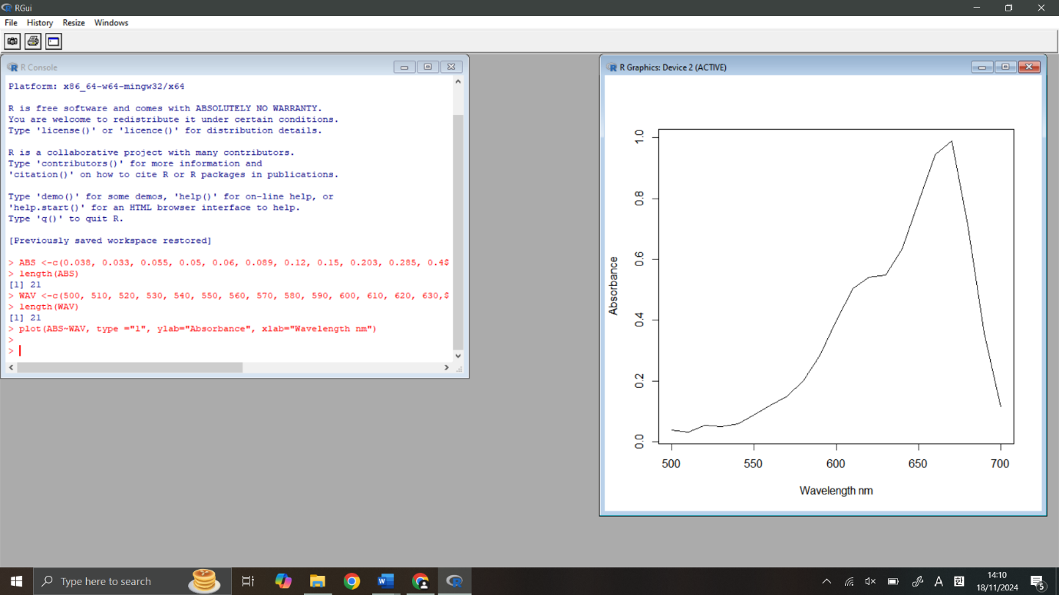sR Studio for Formation of the Absorption Curve
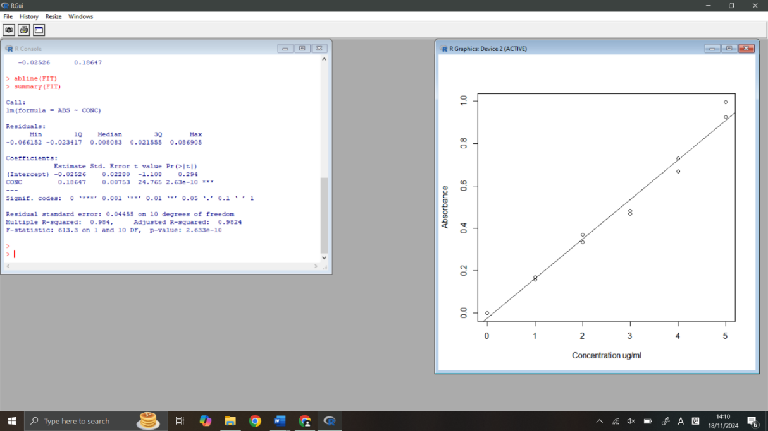
R Studio for Formation of the Calibration Curve

